Northern Ballet

Access Guide

Introduction 3

Getting Here 4

By Train 4

By Bus 4

By Bicycle 5

By Car 5

Parking 6

Reception and Box Office 7

Main Foyer 8

Performances at the Stanley & Audrey Burton Theatre 9

Accessible Dance 12

Café Bar 13

Toilets 14

Ground Floor Toilet 15

First Floor Toilet 15

Second Floor Toilet 16

Third Floor Toilet 16

Fourth Floor Toilet 16

Fifth Floor Toilet 16

Studios and Conference Spaces 17

Additional Information 18

Local Accommodation 18

Park Plaza 19

Leonardo Hotel 19

Local Services for Disabled People 20

Northern Ballet on Tour 21

Future Plans and Notes 22

Welcome to Northern Ballet’s access guide. We hope that you find this information helpful and would welcome any feedback; including suggestions for any other information you think could be usefully included.

Visit our website for a full [virtual tour of our building](https://northernballet.com/our-building/explore-our-home) including a 360° view of our studio.

For more details about access and our facilities please call 0113 220 8000 or email us at [info@northernballet.com](mailto:info@northernballet.com).

This Access Guide has been updated in January 2024. We do not currently operate any building-wide Covid-19 access procedures. If you are in contact with a member of Northern Ballet staff who provides you with different Covid Safe information, please follow those guidelines as the information in this document may be out of date.

# Introduction

Northern Ballet is located on Quarry Hill in central Leeds in the thriving cultural quarter. Local amenities such as the train station, bus station and shopping area of Briggate are accessible by foot or bus.

# Getting Here

## By Train

Leeds Station is located in the city centre and is 0.7 miles away from Northern Ballet. The map below shows the quickest pedestrian route which is fairly even with a slight decline and is well lit with streetlights and should take about 15 minutes, or 5 minutes to drive. There are numerous roads to cross, both with and without pelican crossings.

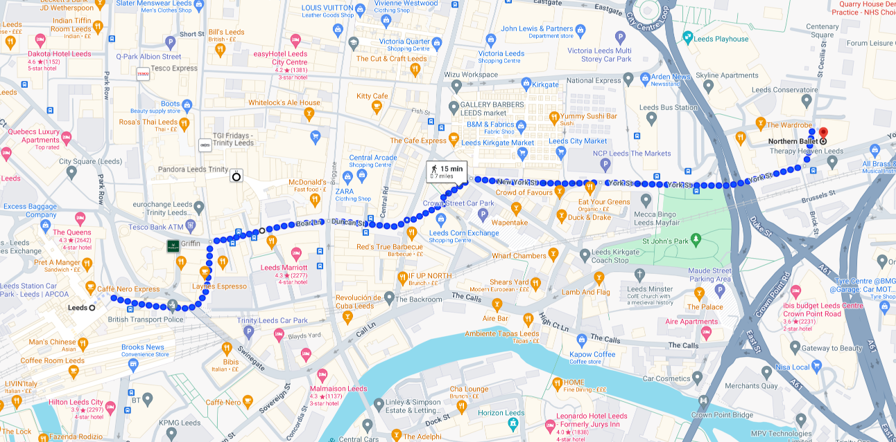

[Visit Google Maps](https://www.google.com/maps/dir/Leeds+Station,+New+Station+St,+Leeds+LS1+4DY/Northern+Ballet,+Quarry+Hill,+Leeds/@53.7959537,-1.5403138,16z/data=!4m19!4m18!1m10!1m1!1s0x48795c1efdf4eb25:0x8a34c051349bc998!2m2!1d-1.5473907!2d53.7949721!3m4!1m2!1d-1.5438138!2d53.795922!3s0x48795c19375c8145:0xd49b5ea1dd20bbfd!1m5!1m1!1s0x48795c16af4c72f7:0xc77282b8014843b3!2m2!1d-1.5323158!2d53.7970084!3e2?entry=ttu) for a detailed pedestrian map for the journey from Leeds Train Station to Northern Ballet.

## By Bus

The Central Bus and Coach Station is opposite the Leeds Playhouse and is 0.1 miles from Northern Ballet. The route from the bus station to Northern Ballet is level and firm, with three pelican-controlled roads to cross. It is lit with streetlights.

There is a bus interchange outside the New Station Street entrance. All Leeds First Buses have a dedicated area for wheelchair users; other passengers are required to volunteer the space for wheelchair users. There are also regular buses from Boar Lane near the train station to York Street near Northern Ballet.

You can find more information about the bus services in Leeds on the [West Yorkshire Metro website](https://www.wymetro.com/).

## By Bicycle

Northern Ballet has a bike shed available for any user of the building to use. Please call us on 0113 220 8000 or email us at [info@northernballet.com](mailto:info@northernballet.com) to ask for the keycode to gain access.

## By Car

Please note that there are ongoing building works in Quarry Hill; this may mean that access to Northern Ballet by car is limited at certain times. Try checking [One Network](https://one.network/uk/leeds) or another traffic monitoring site for road disruptions before traveling.

Northern Ballet is easy to reach from the major road networks via the M621, the postcode for your satnav is LS2 7PA. Please note, the route to Northern Ballet via St Peter’s square is now a one-way system.

### Parking

Northern Ballet does not have a public car park, we have two disabled bays available for Blue Badge holders however we cannot reserve these spots and are therefore offered on a first-come first-served basis.

Additional accessible parking can be found in Leeds Playhouse’s car park, close to Northern Ballet. You can find more information about the parking they have available via their website.

Additional car parking is available nearby:

* [NCP The Markets Car Park](https://www.ncp.co.uk/find-a-car-park/car-parks/leeds-the-markets/) (open 6.00am - 11.00pm)
* Templar Street & Edward Street Car Park (open 24hrs)
* [Victoria Leeds Multi Storey Car Park](https://www.victorialeeds.co.uk/visit/parking/) (John Lewis Car Park, open 24hrs)

You can find more information on [parking in Leeds](https://www.leeds.gov.uk/parking-roads-and-travel/parking) on the Leeds City Council website.

# Reception and Box Office

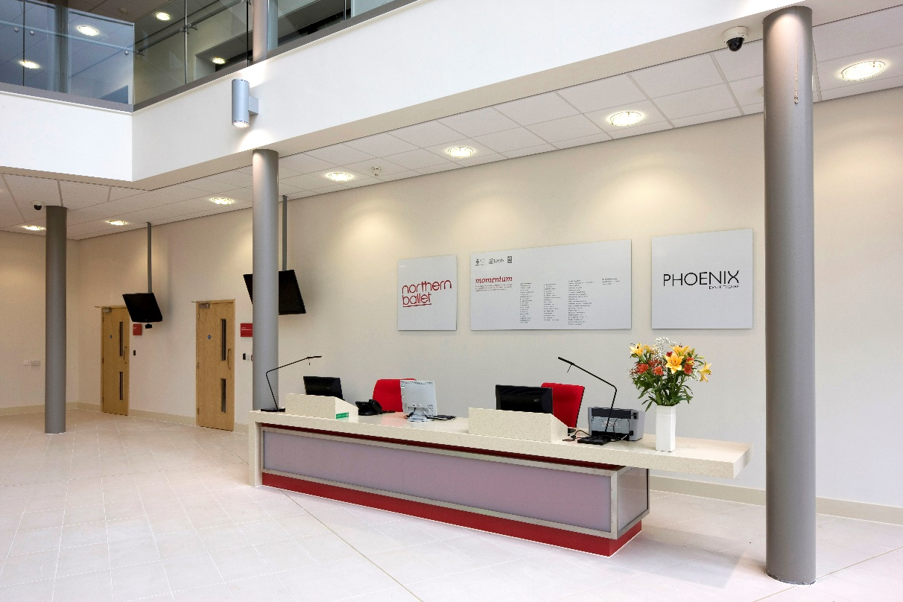

The reception desk is on the right as you enter the building with the café and toilets on the left. There are flat tiles throughout the foyer which is well lit with natural light from the front of the building. At the reception desk, there is a low counter measuring 750mm (29.5 inches) high.

When you arrive, our welcoming reception staff will be able to direct you around the building. Here you can ask for help, directions, ear defenders, or pick up headsets for the hearing loop. The reception desk is also our Box Office, where you can collect tickets for performances at the Stanley & Audrey Burton Theatre. There are visual and braille signs around the building and within the lift. Signage in these spaces is clear to read with a white background and coloured font.

# Main Foyer

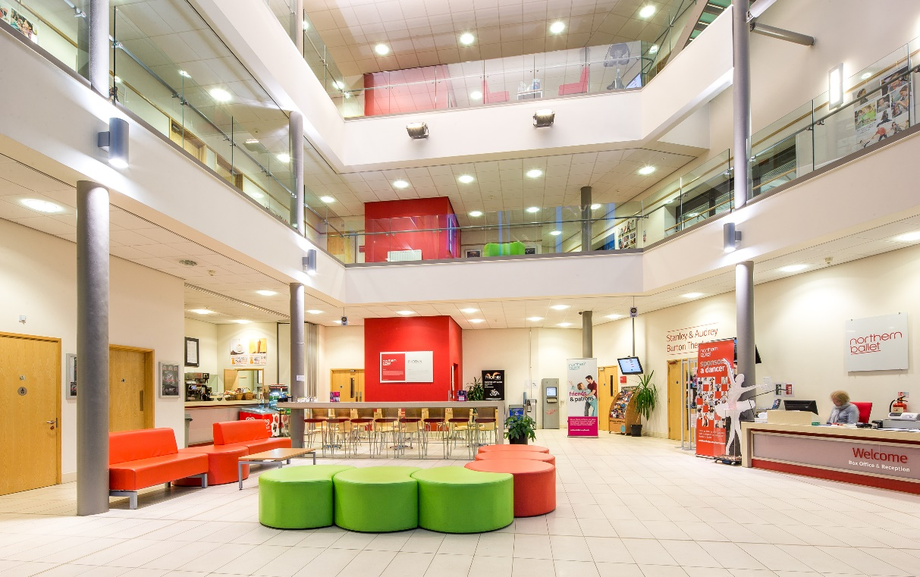

The main foyer is the heart of the building and contains the lift and stair access to all other floors, the reception desk and Box Office. Guide dogs are welcome, our café can provide you with water and a bowl for your dog.

The accessible entrance to the building is through the first door on your left as you look at the building. This is a power assisted door which opens outwards and the button to open the door is on the right-hand side. The door width is 1,040mm (41 inches). There is an intercom on the lefthand side from which a receptionist or the Facilities Assistant can be called for assistance.

# Performances at the Stanley & Audrey Burton Theatre

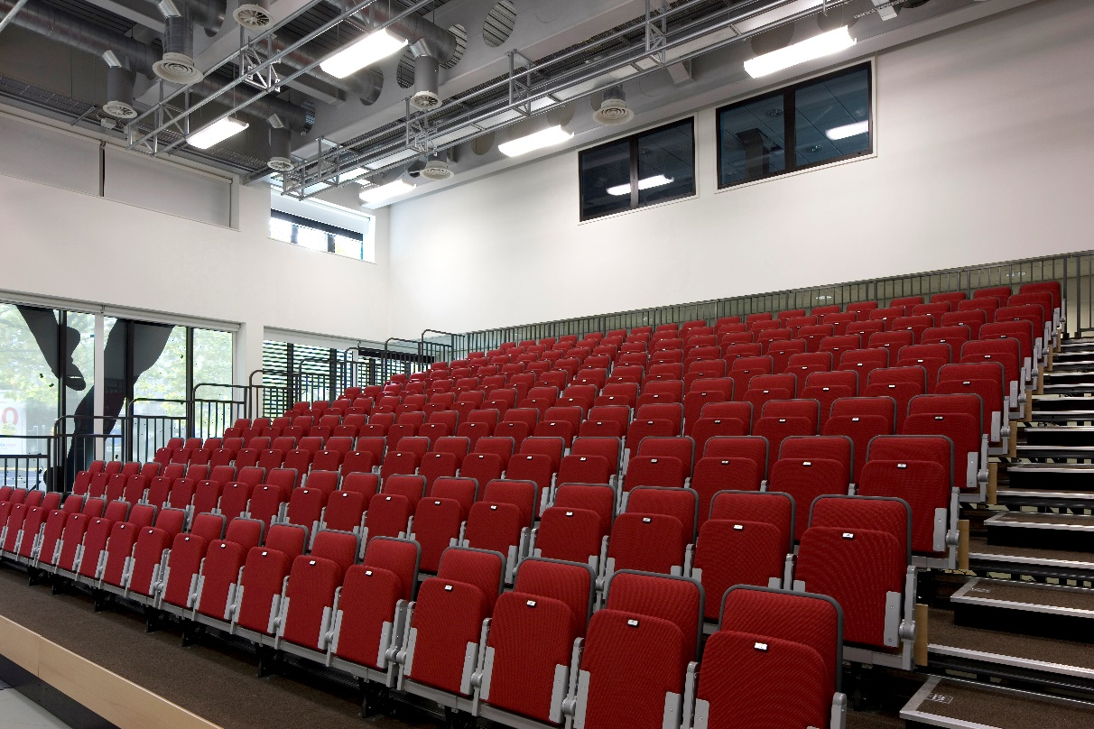

The Stanley & Audrey Burton Theatre is on the ground floor, accessed from the main foyer through a single door 930mm (36.5 inches) wide. The auditorium is a raked bleacher seating bank with shallow steps and handrails up either side. Wheelchair spaces can be booked in the front row on the level access auditorium floor, just ask the reception team when booking tickets.

The floor in the auditorium is carpeted with easily negotiable short pile carpet.

Before and after performances and in the intervals, the access routes are clearly lit, and the doors are secured open. During the performances, stewards are seated to either side of the auditorium and can help you exit with the use of torches. During Relaxed Performances, lights in the auditorium will stay on.

The Stanley & Audrey Burton Theatre is fitted with a hearing loop; headsets and necklaces are available from the Box Office in the main foyer or personal hearing aids should be turned to the T position. Ear defenders are also available on request from the Box Office.

There is space available to store a mobility chair or wheelchair during performances at the theatre. Please let a steward know and they will store mobility chairs or wheelchairs at the back of the auditorium.

The theatre offers a mix of family friendly, dance and theatre performances. We also sometimes offer audio described performances for people who are blind and/or visually impaired, more information can be found on the theatre’s website and event listings.

A free companion ticket can be booked alongside a full price ticket for disabled adults who require assistance. You can [book your tickets online](https://northernballet.com/theatre) (please note wheelchair spaces and seats for Audio Described performances can only be booked over the phone). You’ll be able to pick your own seats from the plan and we’ll send you an e-ticket straight away to confirm your booking. You can also call 0113 220 8008 and our Box Office team will be happy to take your booking.

We are a family friendly venue with these family friendly facilities:

* Baby changing facilities
* Pram storage area
* Level access to the theatre
* We have a number of booster seats available, however, please feel free to bring along your own if you have one
* Ear defenders are available
* Special family lunch packages for selected family performances
* Chill out space and accessible changing room for our [relaxed performances](https://northernballet.com/accessible-performances/relaxed-performances).

# Accessible Dance

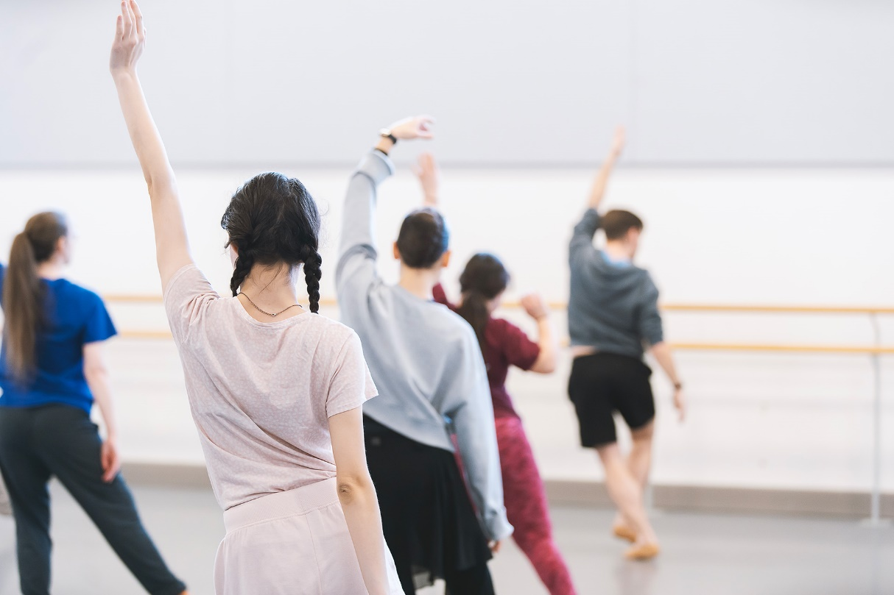

Northern Ballet holds a range of courses including In Motion, a unique programme for self-propelling wheelchair users aged 8+ years to adult, and the Ability dance course which is specifically designed for adults with mild to moderate learning disabilities.

[Find out more about our inclusive dance courses.](https://northernballet.com/join-in/inclusive-dance)

There is also a range of open dance classes for everyone to enjoy.

[Find out more about our open classes.](https://northernballet.com/academy/open-classes-for-all)

While visiting Northern Ballet at Quarry Hill, you can also ask for information about our ballets which tour throughout the UK and often include audio described performances.

# Café Bar

Our café is open Monday to Saturday, 8.30am – 4.00pm. It will be open for performances at the Stanley & Audrey Burton Theatre and you will be able to take refreshments into the auditorium. The café bar is in the main foyer on the ground floor. The area is bright, airy and well-lit with LED lighting.

A level, tiled floor and wide gangway allow easy access to the service area; it can become busy when children are waiting for classes to begin. Orders are taken from the service counter which is 1100mm (43.25 inches) high. Staff are happy to take your order from the table if required.

There are six round wooden tables each set with four wooden and chrome chairs. The tables have 735mm (29 inches) of clear access underneath. There is also a long high bar with 1100mm (43.25 inches) of clear access underneath and eight high stools. This can be busy before performances in the Stanley & Audrey Burton Theatre.

There is also an area to the front of the reception that has soft low furniture available to both café customers and general visitors.

Food and drink are supplied by Catering Yorkshire. Their menu can be found on the wall to the left of the service area, and the drinks menu is located behind the service area; both are printed with large and medium lettering. Staff are happy to read the menu if required. There is a range of hot, cold and dietary options - further dietary options and a full list of allergy related products can be made available upon request. [You can see a sample menu here](https://northernballet.com/theatre/our-building/catering). The café is self-service and hot meals are ordered and brought to your table.

Crockery is white porcelain with metal cutlery; these can be changed upon request to wooden cutlery and paper plates. Babies’ bottles can be heated, and highchairs are available on request. Breast feeding is welcome throughout the foyer and café bar. If you prefer to breast feed in a quiet space, please speak to the receptionist.

# Toilets

There are toilets and accessible toilets on every floor of the building. All toilets are fully stocked with anti-bacterial soap and are checked frequently for stock levels throughout the day.

## Ground Floor Toilet

On the ground floor, there is an accessible toilet which has baby changing facilities. It is unisex and doesn’t require a code or radar key to use.

It has level entry through a 930mm (36.5 inch) wide door, a clear 1m space for a wheelchair on the right and the seat is 460mm (18 inches) high. There are two fixed vertical handrails either side of the wash basin, one fixed vertical handrail to the right of the toilet and one movable horizontal handrail to the right of the toilet.

If assistance is required there is a red pull cord on the left-hand side of the WC which activates an alarm and a flashing light outside the WC.

It is very well lit with fluorescent ceiling light, floored in non-slip lino with extended lever taps on the sink.

## First Floor Toilet

Clearance to the left of the WC with two fixed vertical rails on right hand side of WC, one fixed and one movable horizontal rail at left side of WC and a fixed vertical rail either side of the wash basin.

## Second Floor Toilet

Clearance is to the left of the WC with two fixed vertical handrails either side of the wash basin, one fixed vertical handrail to the left of the WC and one movable horizontal handrail to the left of the WC.

## Third Floor Toilet

Clearance is to the left of the WC with two fixed vertical handrails either side of the wash basin, one fixed vertical handrail to the left of the WC and one movable horizontal handrail to the left of the WC.

## Fourth Floor Toilet

Clearance to the left of the WC with two fixed vertical rails on right hand side of toilet, one fixed and one movable horizontal rail at left side of WC and a fixed vertical rail either side of the wash basin.

## Fifth Floor Toilet

Clearance is to the left of the WC with two fixed vertical handrails either side of the wash basin, one fixed vertical handrail to the left of the WC and one movable horizontal handrail to the left of the WC.

All the accessible facilities have level entry, non-slip lino, wide doors, low seats and red emergency cords next to the toilet.

# Studios and Conference Spaces

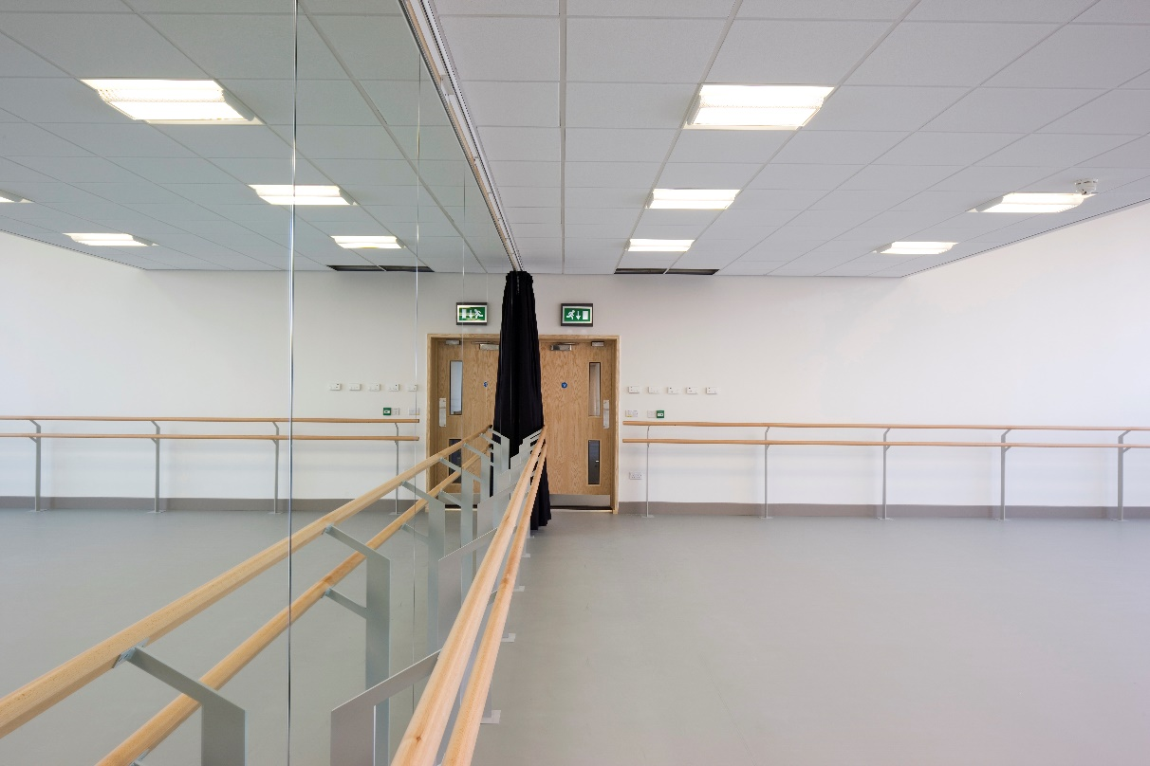

There are seven dance studios and various conference spaces and meeting rooms available for hire throughout the building. All can be accessed via lift or stairs. Our flexible event rooms can be tailored to your needs so please just ask our team when you book your event and they will be happy to help with any requests.

The studios are all harlequin dance floor sealed from wall to wall. Many studios have permanent bench seating along one wall and moveable wooden stools. During conferences and non-dance events, the floors are tiled over with short-pile carpet.

# Additional Information

Assistance and guide dogs are very welcome in Northern Ballet’s building. In the case of an emergency evacuation, all front of house staff have been trained to deal with and assist customers in leaving the building.

There is a large print sheet with information on the building’s facilities available on request. If you have specific needs that you would like to discuss, please contact the reception team on 0113 220 8000 or email [info@northernballet.com](mailto:info@northernballet.com).

Members of our reception, front of house and facilities staff have received basic Makaton communication training and Disability Awareness and Equality training.

# Local Accommodation

Accessible accommodation is available near Northern Ballet and the Stanley & Audrey Burton Theatre. Here are some suggestions; however, these are not endorsed by Northern Ballet.

## Park Plaza

Boar Lane, City Square, Leeds, Yorkshire LS1 5NS

This hotel has a wheelchair accessible public entrance, lobby and public restrooms and accessible rooms which may include the following accessible features:

* Amenities within accessible range to reach
* Audio, visual and sensory emergency warning devices and emergency cords
* Controls operable without grasping or twisting
* Grab bars alongside toilet and by bathtub
* Wider guest room and bathroom doorways

Please contact the hotel on 0333 400 6144 to confirm if an accessible room will meet your needs or if you have additional questions.

## Leonardo Hotel

Brewery Wharf, Brewery Place, Leeds LS10 1NE

This hotel has accessible toilets in public areas, lifts to all floors and a number of accessible wheelchair friendly rooms which include:

* Lowered beds for easy transfer from a wheelchair to the bed
* Wide doorways
* Sufficient floor space to manoeuvre
* Fully accessible bathrooms, including either roll-in shower or bath with additional handrails, lower sink, grab rails and pull cords

Please call Leonardo Hotel on 0113 283 8800 to discuss your requirements and to check availability of accessible wheelchair friendly rooms, or read their [access statement](https://www.leonardohotels.co.uk/pdf/index.html?file=/files/pdfs/jurys_inn_leeds_access_statement_2018.pdf).

There are also accessible rooms available at the following local hotels:

* Quebecs Hotel
  + 9 Quebec Street, Leeds, West Yorkshire LS1 2HA
  + 0113 244 8989
* Hilton Leeds City
  + Neville Street, Leeds, West Yorkshire LS1 4BX
  + 0113 244 2000

# Local Services for Disabled People

There are a number of services available for disabled people in Leeds City Centre. DIAL Leeds (Disability Information and Advice Line) provides a short-term manual wheelchair hire service and can also supply RADAR keys (for accessible toilets).

For more information, DIAL Leeds can be contacted on 0113 226 0311 or by [visiting the DIAL website](https://www.dial-leeds.org.uk/).

# Northern Ballet on Tour

Northern Ballet perform across the UK bringing world-class ballet to a wide range of audiences.

We offer various opportunities for you to take a step closer to the Company and find out more about our productions during your visit to the theatre. Talks and demonstrations give an insight into life of a touring ballet company, offer the chance to see the dancers in training and reveal some of the secrets behind creating a production. And for those with the energy or desire to dance, our movement workshops offer you the chance to have a go, learn some new steps and get creative, whatever your ability. Find out how [you can join in at the theatre and on tour](https://northernballet.com/join-in/events-and-workshops/at-the-theatre-and-on-tour).

We offer [Audio Described performances](https://northernballet.com/accessible-performances/audio-described-performances) of many productions on tour, enabling people with a visual impairment to enjoy our shows. A free accompanying Touch Tour Insight Workshop gives patrons a greater understanding of the production.

[Information about our productions is available on our website](https://northernballet.com/), including scenarios and character lists. Large print cast sheets are available on request following performances. Please email [info@northernballet.com](mailto:info@northernballet.com) or call 0113 220 8000 to request a copy.

The theatres that we visit on tour have a range of facilities to meet your requirements. To find out more, discuss, specific needs and make a booking, please contact the relevant theatre box office.

# Future Plans and Notes

Northern Ballet is committed to ensuring that our building, facilities, and events are as accessible as possible.

We are continuously in the process of updating our website to ensure that information is as clear and easy to access as possible for everyone.

If you have any questions or feedback on our building or this guide, please let us know by contacting [info@northernballet.com](mailto:info@northernballet.com).

All the information in the guide is correct as of January 2024.

Photos by Google Maps, Jonathan Taylor, Karl Andre, and Sophie Beth Jones.