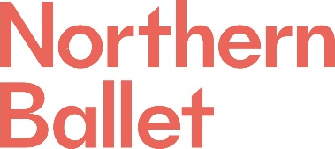

Application Questions

Candidate details

Name
Position applied for | Management Accountant

For office use

Reference
Position applied for | Management Accountant

Please answer the 3 questions below. Your answers should be short, and we ask that you restrict your answers to a maximum of 100 words:

What do you believe is your most relevant experience for this role? (100 words)
What are the key challenges NB are likely to face at the moment? (100 words)
What would you bring to the team here? (100 words)

Please submit your application questions, along with your CV and a covering letter, via our portal:

https://hr.breathehr.com/v/management-accountant-16046

