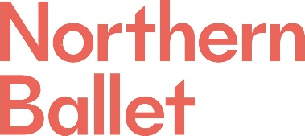

Application Questions

Candidate details

Name
Position applied for | Communications Officer

For office use

Reference
Position applied for | Communications Officer

Please answer the 4 questions below. Your answers should be succinct, observing the word limit indicated:

Reflecting on the Job Description and Person Specification tell us how your experiences and qualifications make you suitable for the role of Communications Officer at Northern Ballet. (500 words)

Tell us about your most successful marketing campaign and what impact it had for the organisation (200 words)
Tell us about your experience of compiling, editing and project managing publications such as programmes or brochures (200 words)
Northern Ballet is a Disability Confident employer. If you have a long-term condition/disability, and you meet the minimum criteria for the post for which you have applied, we guarantee to offer you an interview. Please may you indicate if you have a long-term condition/disability.

Please submit your application questions, along with your CV and a covering letter, via our portal:

https://hr.breathehr.com/v/communications-officer-19211

And please complete the Equal Opportunities form:

https://forms.office.com/Pages/ResponsePage.aspx?id=kiybkTtJZEGj4k_8636-evumevgkAZZBtAtlKnHtkT5UQTRHOFkzVzBRNTMzWFhNQVZQQUlYNDNOVi4u

