Hansel & Gretel

# The Characters

## Hansel

This is Hansel, he loves video games! He’s always messing around and playing with his little sister called Gretel.

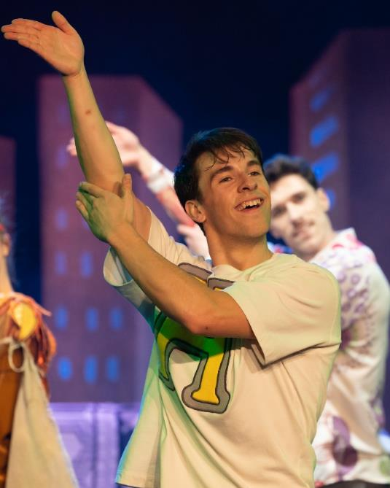]

## Gretel

Gretel is Hansel’s sister, she’s very smart and always has a positive attitude! She also loves to play video games, but doesn’t always share with her brother.

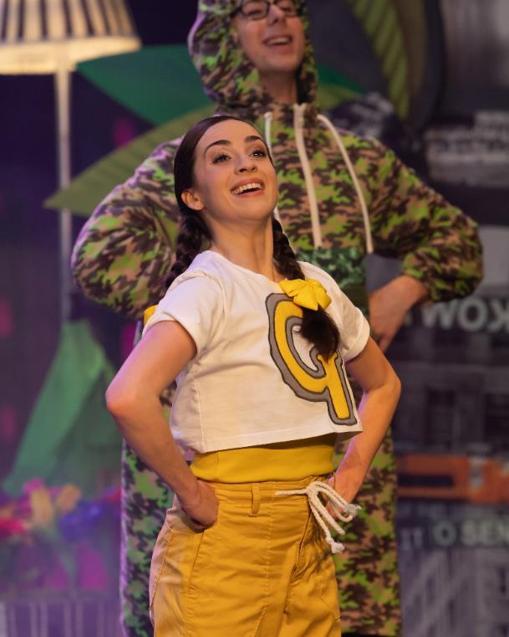

## Dad

They live with their Dad, and he’s often busy at work. He’s always on his phone! He gets annoyed with Hansel and Gretel when they mess around and fight. He loves Hansel & Gretel very much.

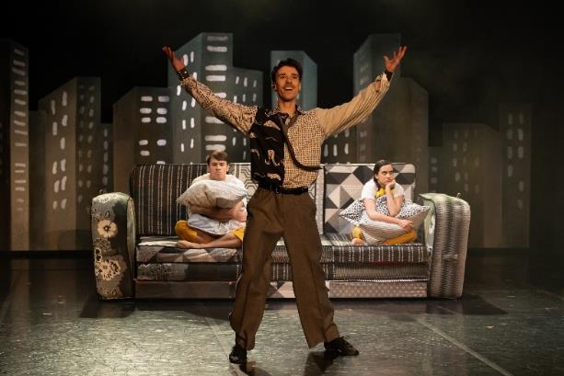

## The Bird Watchers

Hansel & Gretel meet two Bird Watchers called Kate and Tim, and they are on the lookout for rare birds. They’re very enthusiastic, but a little clumsy!

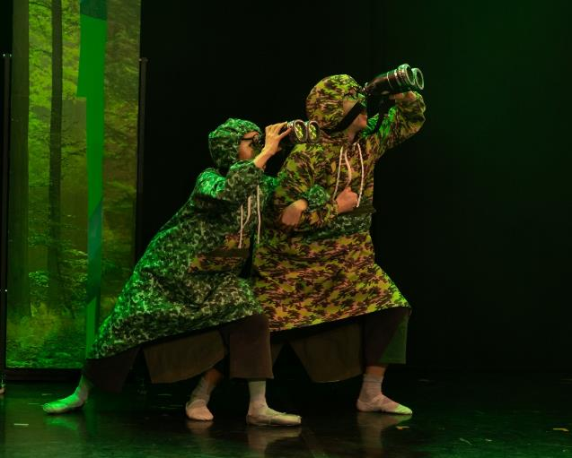

## The Rubbish Monster

He’s a little scary at first and he makes lots of noise, but he’s friendly at heart and just misunderstood.

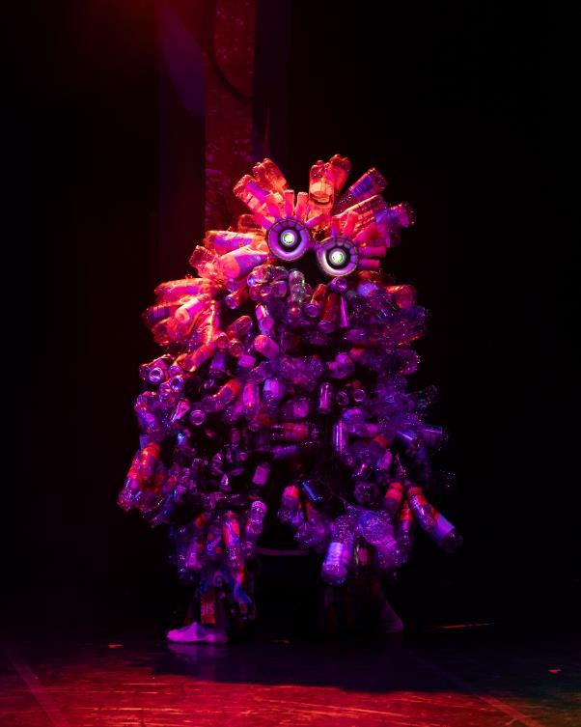

## The Lady of the Wood

The Lady of the Wood loves nature and gardening. She loves to tend her garden and wander through the forest.

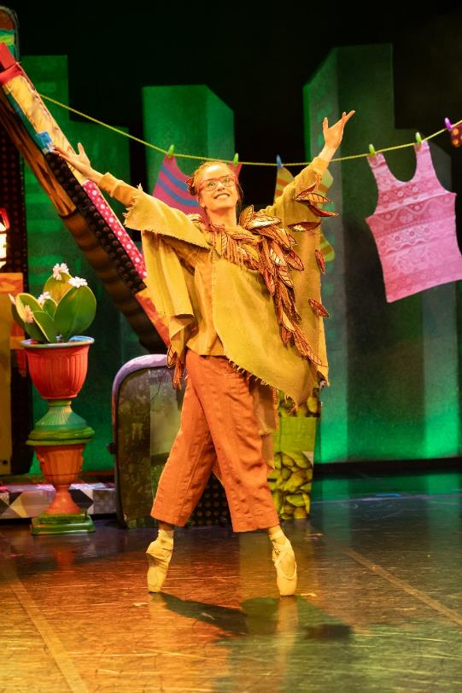

## The Nature Spirits

The Nature Spirits teach Hansel and Gretel about what they can do to take care of where they live. They’re magical spirits that guard the forest. There is a female Nature Spirit and a male Nature Spirit.

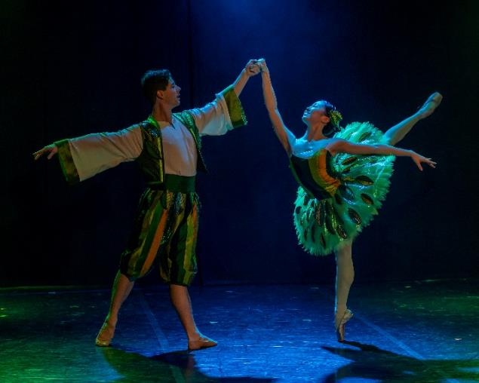

**Stop reading now if you don’t want to know what happens!**

# The Story

Hansel and Gretel are brother and sister. They live with their Dad in a flat in the city.

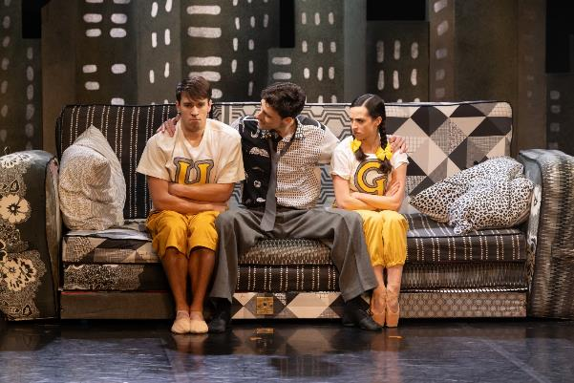

They are playing video games together at home. They start to fight and break the controller. Their Dad sends them outside to get some fresh air.

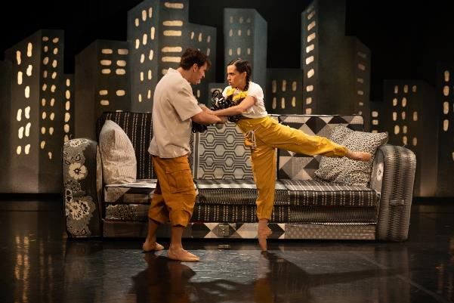

Hansel and Gretel walk into the woods. They drop sweets behind them so they can find their way home.

They come across two bird watchers who ask them to be quiet, so that they can hear the birds singing.

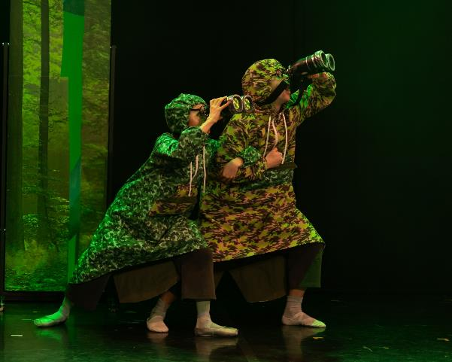

The group start to dance along to the bird song.

A Nature Spirit finds the sweets Hansel and Gretel dropped and thinking they are litter, cleans them up.

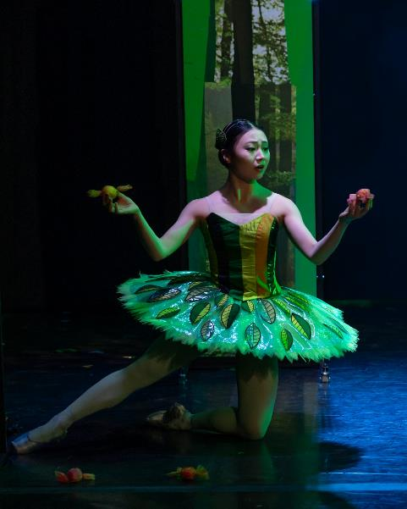

Hansel and Gretel chase the Nature Spirit deep into the woods.

Hansel and Gretel realise they are lost in the woods. As they try to find their way home they start eating their snacks and throwing the rubbish on the floor.

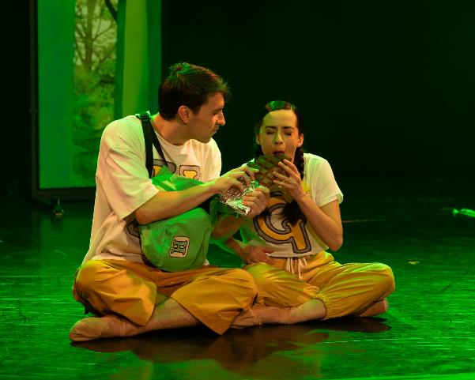

The Nature Spirit re-appears and teaches Hansel and Gretel the damage that littering can do. Hansel and Gretel pick up their wrappers and follow the Nature Spirit.

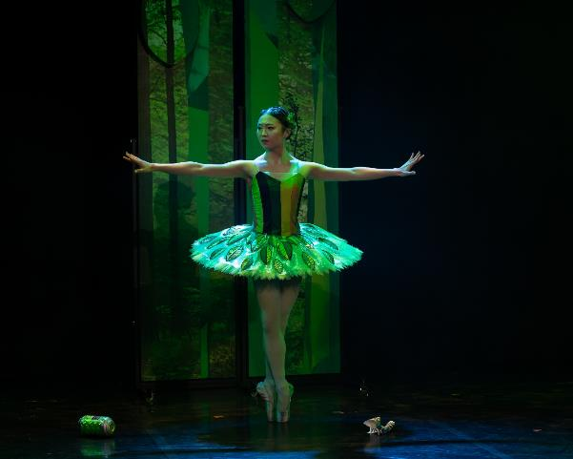

They come across a dump on the edge of the forest. It is home to a creature who is covered in rubbish, called the Rubbish Monster. The Rubbish Monster thrashes angrily, this is quite noisy. He scares Hansel and Gretel and they run away.

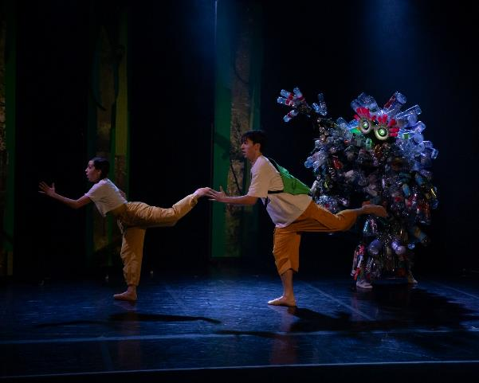

Hansel and Gretel continue running and accidentally knock over some potted plants that are outside a cottage in the forest.

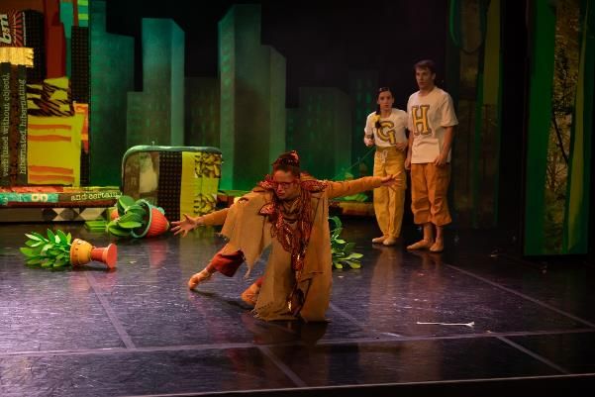

A lady comes out of the cottage and tells Hansel and Gretel off, she’s called the Lady of the Wood. The lady realises that Hansel and Gretel are sorry for breaking the plant pots and they tell her that they’re lost.

She decides to help them find their way home and to say thank you to the lady, they mend her plant pots.

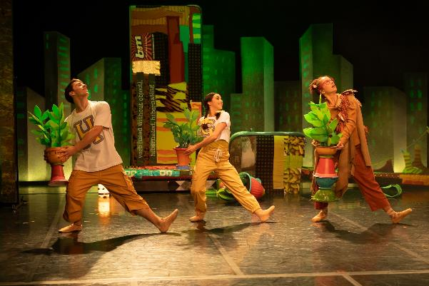

Hansel, Gretel and the Lady of the Wood begin the journey home.

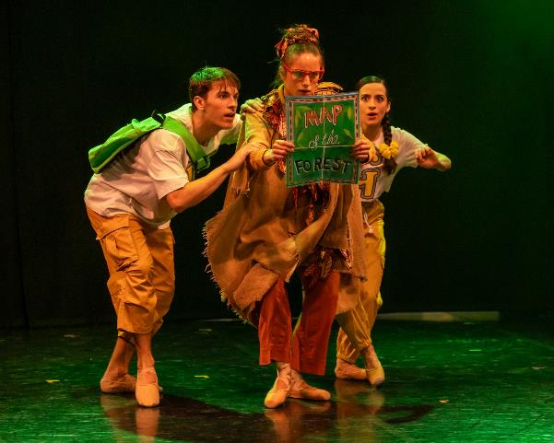

They run into the Rubbish Monster again – don’t forget, he’s noisy as he’s covered in rubbish!

Hansel and Gretel are scared of the Rubbish Monster but the Lady of the Wood shows them that he is kind at heart. The Rubbish Monster is only grumpy because the rubbish makes it hard for him to move!

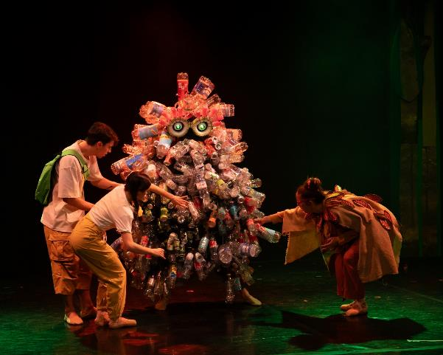

Hansel, Gretel and the Lady of the Wood decide to help the Rubbish Monster. They remove the rubbish that’s piled up on his body and find new uses for it.

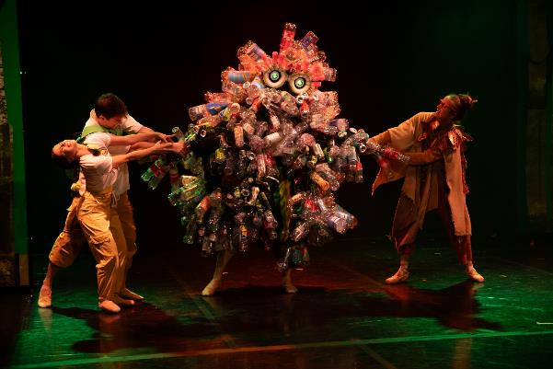

As they remove the rubbish, the Rubbish Monster transforms! They discover he is a Nature Spirit and is overjoyed to be reunited with the other Nature Spirits.



He dances with the female Nature Spirit.

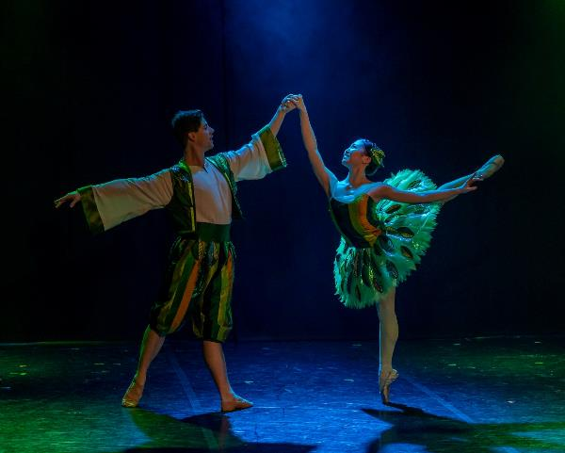

After helping the Nature Spirit, Hansel and Gretel finally arrive home. They tell their Dad about everything they learnt; how to make the world a little greener and find new uses for old things.

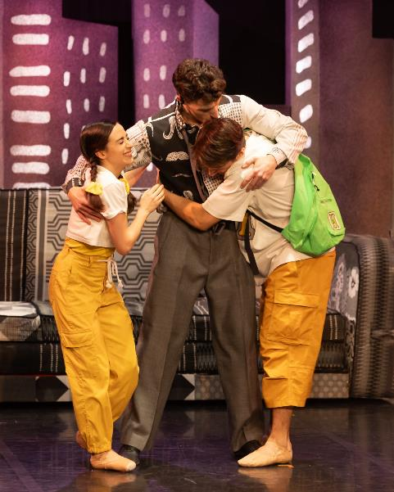

With the help of the Lady of the Wood and the Bird Watchers they all plant flowers in the garden.

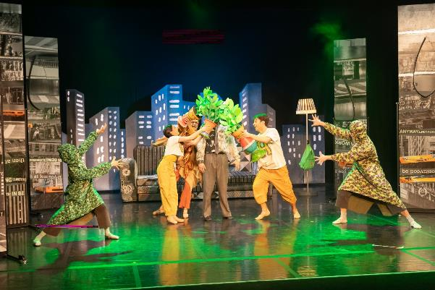

Hansel and Gretel are happy they can help make the world a little cleaner.

**The end**

The dancers all take a bow and the audience will clap and cheer!

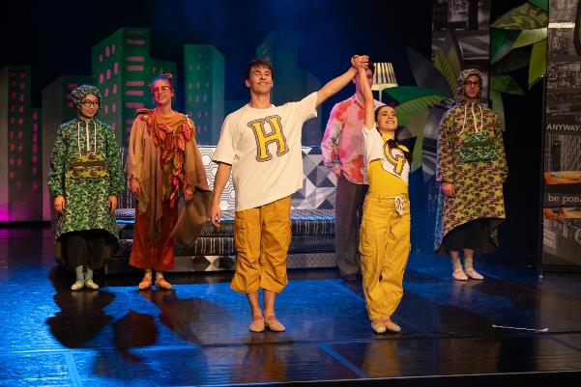

Photos Dave Pearson, George Liang and Emily Nuttall.